Herbaceous Paeony -cultural notes.

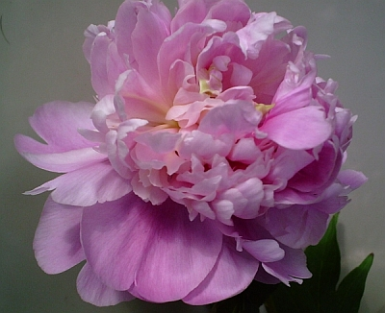
Ray Mills
Phone.03 5473 4242
Mobile.0404 956 810
Email: raysunusualplants@yahoo.com.au
Web: www.raysunusualplants.com

Requirements…
Sun : Full sun to part shade.
Good Drainage: A well drained position is essential as paeonies are prone to root rot. Plant in a raised bed or on a slope.
Soil: pH 6 to 7.5

Plant the crown half cm. to 1 cm. below the surface ...too deep and it will not flower.
Apply a big double handful of dolomite lime in spring and blood and bone or well-rotted animal manure in April and November.
Herbaceous paeonies are cold climate plants and need a winter chill to flower.

If your herbaceous paeony doesn’t flower, insufficient frosts to chill the crown are usually the cause.
**Gardening Australia tip**
If you live in a warmer area, place blocks of ice (4 litre ice-cream containers of water frozen in the freezer) over the planted crowns in MID WINTER, replacing when melted. Continue this for 3 to 4 days and the crown should be chilled enough to flower.

